**Work Summary**

**Project Overview**

The analysis utilized **MySQL** for data extraction and manipulation, combined with **Power BI** for data visualization and dynamic reporting. The aim was to extract actionable insights to support e-commerce decision-making.

**Technologies and Strategies**

1. **SQL Techniques:**
   * **Common Table Expressions (CTEs)** and **Window Functions** to manage complex queries like seasonality trends, YTD/MOM sales, and operational analysis.
   * Aggregation and filtering for insights on customer behavior, revenue, and delivery metrics.
2. **Power BI Capabilities:**
   * Dynamic dashboards with KPIs like revenue, delivery time, and AOV.
   * Filters and slicers to enable detailed segmentation by region, category, and timeframe.
   * **Calendar Table:** Created using the DAX formula:  
     CALENDAR(MIN(orders[order_delivered_date]), MAX(orders[order_delivered_date])), enabling time intelligence.
3. **Key DAX Queries:**
   * **Revenue Metrics:**
     + Total_Revenue = CALCULATE(SUM(order_items[price]), FILTER(orders, orders[order_status] = "delivered" && NOT(ISBLANK(orders[order_delivered_customer_date]))))
   * **AOV:**
     + AOV = DIVIDE([Total_Revenue], CALCULATE(COUNTA(orders[order_id]), orders[order_status] = "delivered" && NOT(ISBLANK(orders[order_delivered_customer_date]))))
   * **Delivery Metrics:**
     + Average_Delivery_Time = CALCULATE(AVERAGE(orders[Delivery_Time_in_days]), orders[Delivery_Time_in_days] <> BLANK())
   * **Loyalty Factor:**
     + Loyalty_Factor = [Purchase_Freq] * [Spend_Per_Customer]
   * **YOY and MOM Growth:**
     + YOY: DIVIDE([Total_Revenue], CALCULATE([Total_Revenue], DATEADD('calendar'[Date], -1, YEAR)), 0) - 1
     + MOM: DIVIDE([Total_Revenue], CALCULATE([Total_Revenue], DATEADD('calendar'[Date], -1, MONTH))) - 1

**Findings and Insights**

1. **Revenue Trends:**
   * Consistent growth in revenue over time. AOV reflects healthy spending behavior.
2. **Customer Insights:**
   * Loyal customers drive repeat purchases and revenue.
   * Targeted campaigns can boost retention and engagement.
3. **Operational Efficiency:**
   * Delivery delays in specific regions indicate scope for improvement.
   * High delivery success rates in certain regions correlate with customer satisfaction.
4. **Seasonality and Peak Sales:**
   * Identified peak sales months and seasonal trends allow inventory optimization and marketing focus.

**Actionable Recommendations**

1. **Sales Optimization:**
   * Expand inventory for high-demand categories like Health and Beauty.
   * Utilize peak season data to align inventory and promotional efforts.
2. **Customer Engagement:**
   * Develop targeted retention campaigns for high-value customers based on loyalty metrics.
   * Enhance personalized marketing to leverage spending patterns.
3. **Operational Improvements:**
   * Address delivery inefficiencies in regions with high average times.
   * Maintain consistent service levels to boost overall satisfaction.
4. **Ongoing Monitoring:**
   * Leverage Power BI dashboards to track KPIs dynamically and adjust strategies based on real-time data.

**Here is a Snapshot of the model in Power BI :**   
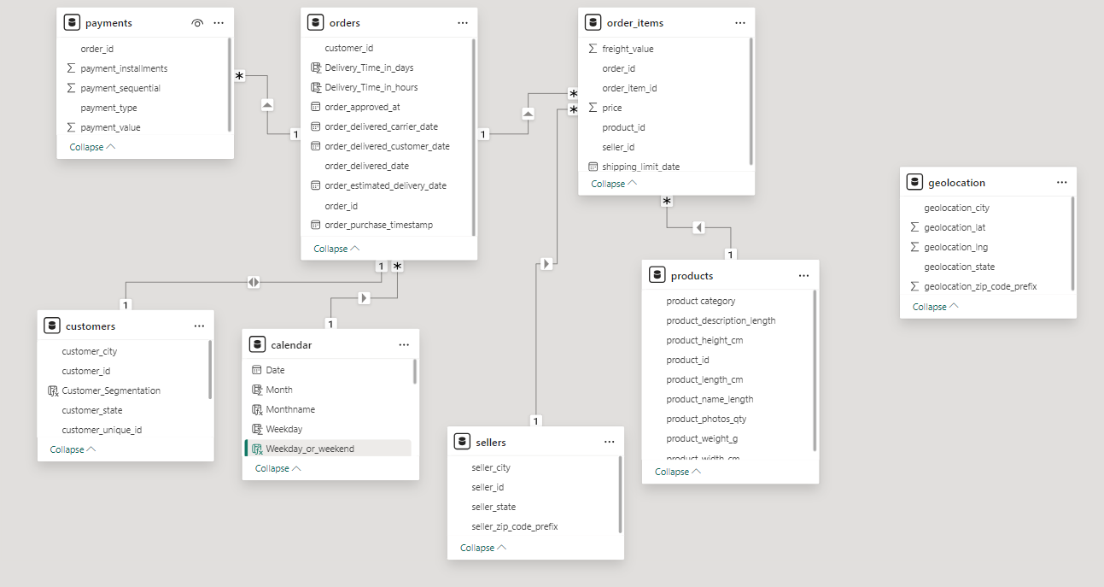

**Rahul_Sahu**